FITFLEX - A PERSONAL FITNESS COMPANION

A PROJECT REPORTED FOR FRONTEND WEB DEVELOPMENT

DEPARTMENT OF COMPUTER SCIENCE

SHRI KRISHNASWAMY COLLEGE FOR WOMENS 2025-2026



SUBMITTED BY

ALMAS BANU S

ABINAYA M

DIVYA DHARSHINI M

KANIMOZHI D

**INDEX**

|  |  |  |
| --- | --- | --- |
| **S.NO** | **TITLE** | **PAGE.NO** |
| 1 | Introduction | 3 |
| 2 | Project Overview | 4 |
| 3 | Nutrition Advise | 10 |
| 4 | Wellness Tips | 11 |
| 5 | Features | 14 |
| 6 | Architecture | 20 |
| 7 | Component Structure | 22 |
| 8 | Setup Instructions | 24 |
| 9 | Folder Structure | 26 |
| 10 | Running the application | 28 |
| 11 | Component Documentation | 29 |
| 12 | State Management | 31 |
| 13 | User Interface | 33 |
| 14 | Styling | 34 |
| 15 | Testing | 36 |
| 16 | Screenshots and Demo | 38 |
| 17 | Future Enhancement | 44 |
| 18 | Conclusion | 45 |

* 1. **INTRODUCTION:**

Fitflex is an innovation personal fitness companion designed to empower users on their journey to health and wellness. It offers **personalized workout plans, exercise tracking, and progress monitoring** tailored to diverse fitness goals and experience levels. Whether the user is a beginner seeking to build a consistent routine or weight loss goals, it adapts to individual needs with intelligent AI-driven

workout recommendation. The app’s intuitive interface allows users to effortlessly explore various workout such as strength training, pilates , HIIT (High-Intensity Interval Training), and full-body routines. Fit Flex Integrates visual exercise demonstrations with detailed instructions, making workouts accessible and engaging. Beyond exercise, it supports nutrition tracking and mindfulness through meal planning and meditation features, providing a holistic approach of fitness.

1.1 Key Introduction Points:

* Personalized workouts for all levels (Abs, Full Body, Pilates, Strength)
* AI-powered adaptive training that evolves with progress
* Nutrition tools: AI food scanner, calorie & macro tracking, meal planning
* Progress tracking: weight, hydration, calories burned visualized
* Mind & body wellness: meditation, Pilates for stress relief & recovery
* User-friendly: home/gym use, workout scheduling, reminders
* Responsive, modern UI with light/dark mode
* Bookmark favorite exercises for easy access

**2. PROJECT OVERVIEW:**

FitFlex is a personalized fitness web application designed to empower users to achieve their fitness goals efficiently and enjoyably. The app offers personalized workout plans, exercise tracking, and progress monitoring through an engaging, responsive, and intuitive interface. It caters to fitness enthusiasts of all levels, from beginners to seasoned athletes, providing features that motivate and guide users throughout their fitness journey.



**2.1 Core Features:**

* **Personalized Workout Plans**: Tailored to individual fitness goals such as weight loss, muscle gain, or endurance improvement.
* **Calorie Tracker**: Track your Calories daily,weekly and monthly.
* **Progress Tracking**: Visual progress charts and goal tracking keep users motivated and informed.
* **Daily Workout Reminders**: Notifications help maintain consistency.
* **Interactive Demonstrations**: Guided step-by-step workout instructions
* **Bookmark Favorite Exercises**: Quick access to preferred workouts.
* **Nutritional tips**: . Get healthy diet suggestions to stay on track.
* **Responsive Design**: Fully functional and visually appealing on both desktop and mobile devices.

**2.2Purpose and goals of the project:**

The purpose of FitFlex is to serve as a **personal fitness companion** that helps users achieve their fitness goals through personalized workout plans, exercise tracking, and progress monitoring. It combines adaptive,nutrition and meal planning tools, making it an all-in-one website for fitness and wellness. FitFlex caters to various goals such as weight loss, muscle building, toning, and overall health improvement, offering equipment-free routines and gender-specific options. It also supports mental wellness with meditation and recovery features. FitFlex aims to make workouts accessible and easy, whether at home or in the gym, providing motivation, clear insights, and holistic support to users on their fitness journey.

**2.3 Workout Plans in Fitness Companion**

Workout plans are a core feature of fitness apps, designed to guide users through structured exercise routines aligned with their individual fitness goals such as weight loss, muscle gain, endurance, or overall health.

**2.3.1 Types of Workout Plans:**

* **Full Body Workouts**: Exercises targeting all major muscle groups in one session, ideal for beginners or those with limited training days.
* **Split Workouts**: Focus on specific muscle groups each day, such as upper body one day and lower body the next, suitable for intermediate and advanced users.
* **Targeted Muscle Group Plans**: Programs dedicated to areas like chest, arms, legs, or core for those aiming to improve specific muscles.
* **Goal-Oriented Plans**: Tailored plans like fat burning, muscle building, strength conditioning, flexibility improvement, or sports-specific training.
* **Bodyweight Workouts**: No equipment exercises using the user’s own body weight, convenient for home workouts.
* **High-Intensity Interval Training (HIIT):** Short bursts of intense activity alternated with rest periods to maximize calorie burn and improve cardiovascular fitness.

**2.3.2 Customization and Flexibility:**

**2.3.4 Workout plans customization is based on**:

* **Fitness level**: beginner, intermediate, advanced.
* **Available equipment**: gym machines, dumbbells, or no equipment.
* **Duration**: sessions ranging from 10 minutes to over an hour.
* **Frequency**: number of workout days per week.
* **Personal preferences**: preferred workout types such as cardio, strength, or yoga.

**2.3.5 How Workout Plans Are Delivered:**

* **Pre-designed Plans**: Users choose from professionally created plans based on their goals.
* **Step-by-Step Guidance**: Each workout includes detailed instructions with text, images, or 3D animated demonstrations to ensure proper form and technique.
* **Progress Tracking**: Users log completed workouts, track improvements, and adjust difficulty over time.

**2.4 Enhancing User Engagement and Results:**

**2.4.1 Features to Support Workout Plans:**

* **Workout Diary**: Logs of completed sessions and notes to monitor consistency and progress.
* **Reminders and Notifications**: Alerts to keep users motivated and on schedule.
* **Integration with Nutrition**: Linking workout plans with diet recommendations to optimize results.
* **Community and Coaching**: Access to trainers or community forums for support and advice.
* **Multiple Workout Types**: Combines strength training, cardio, flexibility, and recovery exercises for balanced fitness.
* **Adaptive Plans**: Based on user's health data, injury history, and goals, workouts adjust intensity and exercises to maximize safety and effectiveness.

**2.4.2 Example Workout Schedule (4-Day Split)**

| **Day** | **Focus Area** | **Sample Exercises** |
| --- | --- | --- |
| **Day 1** | **Upper Body** | **Bench Press, Overhead Press, Pull-ups, Rows** |
| **Day 2** | **Lower Body** | **Squats, Deadlifts, Lunges, Calf Raises** |
| **Day 3** | **Rest or Cardio** | **Light jogging, cycling, stretching** |
| **Day 4** | **Full Body / Core** | **Planks, Burpees , Kettlebell Swings, HIIT** |

**Benefits:**

* Structured workout plans remove guesswork, enabling users to workout efficiently.
* Personalized plans increase adherence by matching user needs and limitations.
* Tracking capabilities provide motivation by showing measurable progress.
* Multi-modal workout types enhance overall fitness, reduce injury risk, and cater to different users.

**3. Nutrition Advice Plan in Fitness Companion:**

A nutrition advice plan is a vital feature in fitness that provides users with tailored dietary guidance, enabling them to complement their fitness routines with optimal nutrition. This plan plays a key role in supporting goals such as weight loss, muscle gain, improved energy, or maintaining overall health.

**3.1 Personalized Meal Planning:**

The nutrition plan is dynamically customized based on user-specific data such as age, weight, height, fitness goals (e.g., fat loss, muscle building), activity level, and dietary preferences or restrictions (vegetarian, vegan, gluten-free). Based on these, the app generates daily or weekly meal plans with detailed portion sizes and macronutrient (carbohydrates, proteins, fats) breakdowns.

Some apps allow users to further personalize their plans by selecting preferred cuisines or excluding ingredients. The flexibility ensures the plans are practical and sustainable, encouraging consistent adoption of healthy eating habits.

**3.2 Features Supporting Nutrition Advice:**

**Grocery List:**

Based on the meal plan, the app can generate grocery shopping lists, simplifyingthe process of ingredient procurement. Recipe suggestions help users prepare balanced, wholesome meals, sometimes including videos

or step-by-step cooking instructions. This turns healthy eating from a challenge into an achievable routine.

**Educational content reminder**:

To promote informed decisions, the app offers nutritional tips covering portion control, hydration, balanced diet principles, and the benefits of various nutrients. Reminders and notifications encourage users to log meals consistently, drink adequate water, and avoid common diet pitfalls.

**Integration with Fitness Data and Motivation:**

* By syncing with exercise tracking, the nutrition advice plan adjusts calorie goals in response to physical activity data, ensuring energy intake properly supports workout demands and recovery.
* Additionally, motivational tools such as goal setting, progress badges, and community challenges help maintain user commitment to nutrition goals, driving long-term behavior change.

**Specialized Diet Support:**

Some apps cater to users following special diets like keto, paleo, or low-FODMAP, providing curated meal plans and ingredient alternatives that comply with these regimens, expanding usability to diverse user needs.

**3.3 Benefits of Nutrition Advice Plans:**

* Enables balanced, goal-oriented eating to enhance fitness results.
* Reduces the complexity of meal planning and calorie tracking.
* Encourages healthier, sustainable eating behaviors.
* Motivates users through progress tracking and community engagement.
* Integrates nutrition seamlessly with exercise for holistic wellness.

Fitness companion apps with robust nutrition advice plans empower users not just to work out harder, but also to eat smarter, transforming nutrition from an abstract concept into a personalized, manageable lifestyle component

**4. Wellness Tips for a Healthy Life:**

**4.1 Wellness:**

Wellness is a holistic state of physical, mental, and emotional well-being. Prioritizing wellness in daily life promotes longevity, reduces the risk of chronic diseases, increases energy, and enhances overall happiness. Below are essential wellness tips to help foster a balanced, fulfilling lifestyle.

**1. Prioritize Balanced Nutrition:**

* Eating a well-balanced diet rich in whole foods energized with fruits, vegetables, lean proteins, whole grains, and healthy fats is foundational.
* Avoid processed foods, excess sugar, and saturated fats while incorporating hydration through water or other low-calorie drinks.

**2. Stay Hydrated:**

Drinking adequate water daily supports digestion, skin health, toxin elimination, and energy. Aim for at least 6-8 glasses of water, adjusting for activity level and climate.

**3. Get Quality Sleep:**

Sleep is critical for healing, cognition, and emotional health. Adults generally need 7-8 hours of restful sleep per night. Establish consistent sleep routines by minimizing screen time before bed, managing stress, and creating a restful environment.

**4. Engage in Regular Physical Activity:**

Moving your body daily boosts cardiovascular health, muscle strength, mood, and brain function. Incorporate at least 150 minutes weekly of moderate exercise like walking, cycling, or yoga, along with strength training twice a

week.

**5. Practice Stress Management:**

Chronic stress undermines health. Engage in relaxation techniques such as deep breathing, meditation, or hobbies that bring joy. Also consider journaling, listening to music, or spending time in nature.

**6. Cultivate Positive Social Connections:**

Healthy relationships boost emotional resilience and longevity. Set aside time for family, friends, and community engagement. Seek support when needed and nurture bonds through communication and acts of kindness.

**7. Foster a Positive Mind set:**

Starting the day with intention—through affirmations, gratitude journaling, or quiet reflection—can improve outlook and motivation. Embrace challenges as growth opportunities and practice self-compassion during setbacks.

**8. Take Breaks From Technology**

Reduce digital overload by setting boundaries on screen time. Engage in offline activities and take regular breaks from work to rest your eyes and

mind.

**9. Prioritize Preventive Health:**

Regular health check-ups, dental visits, and screenings help catch issues early. Follow vaccination schedules and adopt safe health practices.

**10. Maintain a Healthy Environment:**

Keep living and workspaces clean, organized, and filled with natural light. Incorporate plants for air quality and mood enhancement.

**11. Embrace Lifelong Learning:**

Trying new hobbies, reading, or attending workshops keeps the brain engaged and resilient.

**12. Practice Mindful Consumption:**

Limit intake of alcohol, avoid smoking, and be cautious with medications or supplements.

**5.Features:**

**5.1HTML:**

HTML (HyperText Markup Language) is the standard language used to create and structure content on the web. It defines the basic framework of a webpage by using elements called tags, such as headings, paragraphs, links, images, and tables. HTML provides the foundation upon which other technologies like CSS (for styling) and JavaScript (for interactivity) are applied. Every webpage on the internet is built with HTML, making it the backbone of web development.

**5.1.2 Features**:

* Markup language for web content
* Tag-based structure (headings, paragraphs, links, images)
* Supports multimedia (audio, video, canvas)
* Semantic elements (header, footer, article, section)
* Forms and input elements support user interaction
* Hyperlinking capability through <a> tags
* Compatible with CSS and JavaScript for style & behavior
* Responsive design support with media queries (HTML5)
* Platform and browser independent

**5.1.3 Applications**:

* Website structure and content markup
* Email templates
* Web apps frontend layout
* Multimedia embedding
* Mobile and desktop responsive content
* Data storage with XML-like extension

**5.1.4 Advantages:**

* Easy to learn and use
* Universal browser support
* Lightweight, fast loading
* Free and requires no special software
* Flexible with loose syntax
* Integrates well with CSS and JavaScript
* Enables creating structured, responsive content
* Template use simplifies design
* Widely used and well documented

**5.1.5 Disadvantages:**

* Static content only (needs JS for dynamic interaction)
* Limited styling by itself (needs CSS)
* No built-in security or data handling
* Larger projects can be hard to maintain without templates/frameworks
* Browser compatibility quirks (especially older browsers)
* Cannot handle complex functionality alone

**5.2 CSS:**

CSS (Cascading Style Sheets) is a style sheet language used to describe the presentation of a webpage. While HTML structures the content, CSS controls how that content looks—such as colors, fonts, layouts, spacing, and responsiveness. It allows web developers to separate content from design, making websites more visually appealing and easier to maintain. CSS can be applied in three ways: inline, internal, and external. With features like selectors, properties, and media queries, CSS plays a key role in creating modern, user-friendly, and responsive websites.

**5.2.1 Features**:

* Utility-first framework
* Predefined utility classes
* Responsive design with media queries
* Customizable via config files
* Direct styling in HTML
* Supports light/dark mode
* Mobile-friendly

**5.2.2 Applications**:

* Rapid web UI development
* Custom component styling
* Responsive website design
* Prototyping and production apps
* Single-page applications (SPA)

**5.2.3 Advantages**:

* Faster styling process
* High customization control
* No need for separate CSS files
* Stable and bug-minimal
* Easy responsive and mobile support
* Reduces CSS bloat with PurgeCSS
* Flat learning curve if familiar with CSS

**5.2.4 Disadvantages:**

* Steep learning curve for beginners
* Mixes HTML with styling (violates separation of concerns)
* Large verbose HTML files
* Need to recreate default styles (buttons, navbars)
* Limited ready-made UI components
* Requires installation and build setup
* Can lead to repeated code elements

**5.3 javascript**:

JavaScript is a powerful scripting language used to make webpages interactive and dynamic. While HTML structures the content and CSS styles it, JavaScript adds functionality—such as form validation, animations, interactive menus, pop-ups, and real-time updates. It runs directly in the browser, allowing developers to create engaging user experiences without requiring page reloads. JavaScript is also widely used with modern frameworks and libraries, making it a key technology in web development.

**5.3.1 Features:**

* Lightweight scripting
* Interpreted language
* Dynamic typing
* Multi-paradigm: functional & OOP
* Event handling
* Asynchronous programming (promises, async/await)
* Prototype-based inheritance
* Cross-platform & browser support
* DOM manipulation
* Client-side validations
* Template literals & arrow functions
* Rest/spread operators
* Modules and imports

**5.3.2 Applications**:

* Web page interactivity
* Form validations
* DOM manipulation & animations
* Single-page applications (React, Angular, Vue)
* Backend development (Node.js)
* Mobile apps (React Native)
* Game development
* Server-side scripting
* API integration & AJAX requests

**5.3.3 Advantages**:

* Easy setup, no compilation
* Runs in all modern browsers
* Full-stack development capability
* Large community & ecosystem
* Supported by numerous libraries/frameworks
* Enables dynamic and responsive UI
* Rich APIs & built-in methods
* Quick prototyping

**5.3.4 Disadvantages**:

* Dynamic typing may cause runtime errors
* Browser inconsistencies
* Security risks (XSS attacks)
* Performance issues in complex apps
* Callback hell (can be mitigated via promises/async)
* Debugging can be complex
* Lack of strict typing (mitigated with TypeScript)

**5.5 REACT.JS**:

React.js is a popular open-source JavaScript library developed by Facebook for building fast, interactive, and dynamic user interfaces. It follows a component-based architecture, where complex UIs are broken into reusable pieces called components. React uses a virtual DOM (Document Object Model) to efficiently update and render only the parts of a webpage that change, making applications faster and more responsive. It is widely used for developing modern single-page applications (SPAs) and is supported by a strong community and ecosystem of tools.

**5.5.1 Features:**

* Virtual DOM
* Component-based architecture
* JSX (JavaScript XML)
* One-way data binding
* State management with hooks
* React Router for navigation
* Server-side rendering (SSR)
* Reusability
* Declarative UI

**6.5.2 Applications:**

* Single-page applications (SPAs)
* Dynamic websites
* Enterprise dashboards
* Mobile apps (React Native)
* E-commerce sites
* Social media platforms
* Data visualization

**6.5.3 Advantages**:

* High performance (due to Virtual DOM)
* Reusable components
* SEO-friendly (with SSR)
* Large community and ecosystem
* Easy to learn and maintain
* Cross-platform compatibility
* Rich developer tools

**6.5.4 Disadvantages**:

* Steep learning curve for advanced concepts (hooks, JSX)
* Not a full framework (needs additional libraries)
* Frequent updates requiring continuous learning
* Initial setup complexity in large projects
* Limited built-in routing and state management (needs extras)
* SEO challenges with client-side rendering only

**6.Architecture:**

* **HTML & CSS:** HTML and CSS are the core building blocks of web development. HTML provides the structure of a webpage by organizing content into elements such as headings, paragraphs, images, and links. With the introduction of HTML5, developers gained new semantic tags and multimedia support, making websites more meaningful and user-friendly. CSS, on the other hand, controls the design and appearance of these elements. It allows developers to apply styles such as colors, fonts, spacing, layouts, and even advanced effects like animations and transitions. Modern CSS3 features like Flexbox and Grid make it easier to create responsive designs that adapt to different devices. Together, HTML and CSS form the foundation of every website, ensuring both structure and style are effectively combined to deliver a smooth user experience.
* **JavaScript:**

JavaScript is an essential part of modern web development because it allows websites to be more interactive and engaging. It can respond to user actions such as button clicks, mouse movements, or keyboard inputs, making webpages dynamic instead of static. JavaScript is also capable of manipulating the Document Object Model (DOM), which means it can change content, styles, or structure of a page in real time without reloading. With the growth of HTML5, JavaScript gained access to powerful APIs for handling graphics, storage, geolocation, and multimedia. Beyond the browser, JavaScript is also used on the server side with technologies like Node.js, making it one of the most versatile programming languages. Its wide adoption, simplicity, and huge ecosystem of libraries and frameworks make JavaScript a core skill for every web developer.



**7. Component Structure :**

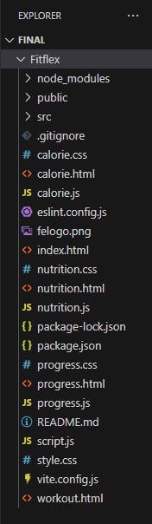

**7.1 State Management Approach:**

* Global State: Managed using React Context API, which centralizes key app-wide states such as workout tracking data, theme settings (light/dark mode), and daily workout reminders. Context API provides a lightweight way to share state across various components without prop drilling, suitable for handling global app settings and user preferences.
* Local State: Managed via React’s useState hook within components, ideal for UI-specific or temporary states like form inputs, toggles, and component-level interactions. This keeps state localized and reduces unnecessary re-renders elsewhere.
* Advantages: Combining Context API with local React state enables scalable management where global concerns are shared appropriately, while individual components maintain their own internal state logic for responsiveness and performance.

**7.2 Routing:**

React Router coordinates navigation between pages like Home, Categories, Workout Details, and Profile, invoking different component trees as needed. the entire page, routing updates the displayed component based on the URL, creating a seamless user experience.

**Core Routing Concepts:**

* **Browser Router:** The root provider that enables routing based on the browser’s history API.
* **Routes and Route**: Routes acts as a container. Each Route maps a URL path to a specific component, rendering that component when the path matches.
* **Link and Nav Link:** Components for navigation—clicking them updates the URL and triggers the correct component to display, without a page reload.

**8. Setup instruction:**

**8.1 Prerequisites:**

The main software prerequisites and dependencies are designed to support frontend development, package management, and third-party integration.

**Node.js :** Required for running JavaScript on the server and managing development workflows.

**React.js:** The core UI library for building interactive components and user interfaces.

**Development Tools**: Code editor (VS Code), browser with developer tools, and optionally testing libraries.

**8.2 Installation:**

**Step 1: Clone the Repository**

* Go to the GitHub page of the repository you want to clone.
* Click on the "Code" button, and copy the repository URL (either HTTPS or SSH).
* Open your terminal or command prompt.
* Navigate to the directory where you want to clone the project.

Run the command:

text

git clone [repository-URL]

* Press Enter: This creates a local copy of the project.

**Step 2: Install Dependencies**

Change directory into the cloned project folder:

text

cd [project-folder-name]

* Run the command to install the Node.js dependencies listed in the package.json file:

text

npm install

* This will download and install all required packages locally in the node_modules folder.

**Step 3: Configure Environment Variables**

* Check if the project has a file named .env.example or similar. This file usually contains environment variable templates.
* Create a new file named .env in the root of the project directory (if it doesn’t exist).
* Copy the variables from the example file or as instructed by the project documentation into the .env file.
* Edit the .env file to set values for each variable according to your environment (e.g., API keys, database connection strings).
* Save the .env file.

text

REACT_APP_FITNESS_API_KEY=your_api_key_here

**Step 4: Start the Application**

Launch the local development server:

text

npm start

**9.Folder Structure:**

**9.1Client**:

* **pages/**  
  Contains top-level page components corresponding to application routes or views, such as HomePage, WorkoutPage, ProfilePage. Each page folder may include related subcomponents, styles, and tests collocated for clarity.
* **assets/**  
  Holds static files like images, fonts, icons, and sometimes style-related assets such as global CSS or Tailwind configuration files.
* **contexts/**  
  Includes React Context providers and state management logic that deal with global app states like theme, user authentication, or workout progress.
* **hooks/**  
  Contains custom React hooks used throughout the app for abstraction and reuse of logic, e.g., useFetchWorkouts, useTheme.
* **services/**  
  Includes modules responsible for making external API calls, data fetching, or business logic separated from UI components.
* **utils or helpers/**  
  Utility functions and helpers that are used across multiple parts of the app such as date formatting, calculations, or validations.
* **tests/ (optional)**  
  Some projects keep tests alongside components; others keep a centralized tests folder.

**9.1.1 Additional Best Practices:**

* Use feature-based grouping in larger projects, where all files around a particular feature (components, hooks, context, tests) are kept in one folder.
* Use index.js files as "barrel" exports for cleaner imports.
* Separate styling concerns within components or using global styles as per project needs.

**9.2 Utilities and Helper Functions**

* **Data Formatting Helpers**: Functions to group and format workout data by date or exercise, making the UI presentation more user-friendly (e.g., grouping workouts by day or muscle group).
* **API Interaction Helpers**: Functions that abstract the fetching, saving, and updating of workout and exercise data from APIs or databases, enabling cleaner separation of concerns in components.
* **Validation and Filtering**: Utility functions for searching and filtering exercises or workouts based on user input (e.g., filtering exercise lists as search terms change).
* **Date and Time Helpers**: Functions to handle date formatting, sorting workouts by recent dates, and calculating workout durations or intervals.

**9.2.1 Custom React Hooks**:

* **UseFetchWorkouts**: A custom hook to retrieve and manage workouts data asynchronously while handling loading and error states.
* **UseTheme:** A hook to handle theming logic, including toggling between light and dark modes and persisting the theme preference.
* **UseWorkoutTracker**: Manages workout session state locally, including sets, reps, weights, and progress within a workout session.
* **UseSearch**: Manages search input state and filtered results for dynamic UI updates.

**10.Running the Application:**

**Step 1: Open Terminal**

Open your terminal or command prompt on your computer.

**Step 2: Navigate to the Client Directory**

Change directory to the frontend client folder where the React application is located:

text

cd client

**Step 3: Install Dependencies (If not already done)**

Install the dependencies required for the React app by running:

text

npm install

This installs all necessary packages listed in package.json.

**Step 4: Start the Frontend Server**

Run the command to start the React development server:

text

npm start

**11.Component Documentation:**

**11.1 Daily workout reminder:**

A daily workout reminder is a valuable feature designed to help individuals maintain consistency, motivation, and accountability in their fitness routines. It functions by sending timely notifications or alerts that prompt users to perform their scheduled exercise sessions, improving adherence to training plans and overall fitness progress

**11.2 Reusable components:**

Reusable components in web frontend development,are independent, customizable UI elements that can be used across different parts of an application to maintain consistency, reduce code duplication, and improve maintainability. Here are some commonly used reusable components and their typical configurations:

**11.2.1 Button Component**

* Accepts props like text (button label), styleClass (CSS styles), and onClick (event handler)
* Configured by passing different labels, styles, and click actions via props.
  + 1. **Input Field Component**
* Takes props such as type (text, email, password), placeholder, value, and onChange.
* Used for forms and can be reused with different input types and handlers

**11.3 Calorie Tracker in Fitness Companion:**

A Calorie Tracker in a fitness companion web application usually works by allowing users to input the foods they consume along with their nutritional details such as calories, protein, carbs, and fats. The app then calculates the total calorie intake and compares it against a user’s daily calorie goal or limit. It can display warnings or alerts if the limit is exceeded and provides an interface to view, edit, or delete logged items.

**11.3.1 How it is typically implemented :**

1. **User Input:** Users enter food items with details like calories, protein, carbs, fat, and quantity through an interactive form.
2. **State Management:** The app manages a list of these nutrition items in state, often using React hooks such as useState or a state management library.
3. **Calculation:** The total calorie intake is computed by summing the calories of all items (considering quantity).
4. **Display:** The app displays the nutrition items in a list or card format, showing individual and total calorie counts.
5. **Editing:** Users can edit or delete previously entered foods to keep track updated.

**12. State management:**

Global state management in React, as implemented in FitFlex, primarily uses the React Context API to create a centralized state that can be accessed by components throughout the application, eliminating the need for prop drilling.

**12.1How Global State is Managed and Flows in the Application:**

* A **Context Provider** is defined, which stores the global state and functions to update this state. It wraps the entire app (or relevant component subtrees) so any nested component can access the shared state.
* The global state includes shared data such as the current user’s workout progress, theme preferences (light or dark), and settings like daily workout reminders.
* Components consume the state using the useContext hook, which gives them direct access to the context values (state and update functions).
* State updates are performed via functions provided by the context, causing React to re-render all components subscribed to that context with the latest data.
* This top-down flow ensures a single source of truth for global states, improving consistency and making state management easier to reason about.
* Using Context API for fitness app state balances simplicity and scalability, suited for medium-complexity applications like FitFlex without the overhead of more complex libraries (e.g., Redux).

**12.2Handling of Local State:**

* **useState Hook**: Each component uses useState to hold and manage its own internal state. This state governs data or UI elements that are specific to that component, such as input values, toggle switches, modal visibility, or temporary form data.
* **Encapsulation**: Local state is fully encapsulated within the component, meaning updates to this state only cause that component (and its children) to re-render, optimizing performance.
* **Example**: A workout input form component might use local state for managing the current text input, selected exercise options, or current step in a multi-step workflow.
* **State Updates**: State is updated via setter functions returned by useState, typically triggered by event handlers like onChange, onClick, or onSubmit inside the component.
* **Isolation**: Multiple instances of the same component have independent state. For example, if two workout timers are rendered, each manages its own timer state separately.
* **Local vs Global**: Local state is appropriate for managing UI-specific data that does not need to be shared with other parts of the app. More complex or shared states (like user progress or theme) are managed globally via Context API.

**13.UserInterFace:**

FitFlex showcases a modern, sleek, and user-friendly interface in its web and mobile app versions, offering various UI features for fitness tracking, workout plans, and nutrition.

**13.1Available UI Showcases for FitFlex**

* **Mobile App UI Preview**: A modern, mobile-first gym app UI featuring workout tracking, class bookings, and personal trainer connectivity with intuitive navigation and energetic design. It highlights pages like workout lists, progress screens, and booking forms.
* **Dribbble Designs**: Screenshots showcase FitFlex's workout and fitness app UI designed for easy navigation with clean layouts, video tutorials, and informative podcasts. The design focuses on customizable workout plans, training activities, and performance tracking with a visually engaging style.
* **App Store and Google Play Screenshots**: These show detailed app screens like personalized workout plans, AI-powered nutrition/meal tracking forms, progress trackers, and mindfulness features with polished UI/UX enhancements.
* **FitFlex Website Template**: The online presence includes a dark modern fitness studio website template for web frontend with sleek visuals and dynamic features projecting strength and professionalism.
* For detailed screenshots or GIFs of specific UI pages like forms, workout plans, reminders, or nutrition trackers, official app store pages, Dribbble, and design preview sites like RapidNative and Behance provide rich visual references that can be explored further.

**14.Styling**:

In CSS styling, especially with Tailwind CSS (which is commonly used in modern frontend projects like FitFlex), the approach centers around utility-first classes that apply one style property at a time directly in the markup.

**14.1 Key Aspects of Styling:**

* **Utility Classes**: Styling is done by combining many small, single-purpose CSS classes (utilities) within HTML or JSX elements. For example, classes like bg-blue-500 (background color), text-white (text color), and py-2 (padding on the y-axis) can be combined to style buttons or other components quickly.
* **Responsive Design**: It supports responsive prefixes (e.g., md:, lg:) to apply styles at different screen sizes, enabling easy mobile-first and adaptive layouts.
* **Variant States**: States like hover, focus, dark mode, and group-hover can be styled with specific variants in class names (e.g., hover:bg-indigo-600, dark:text-gray-200), allowing interactive and dynamic UI styling.
* **Customization**: It can be extended with custom styles, colors, fonts, and spacing through configuration files (tailwind.config.js). It supports directives like @apply to reuse sets of utility classes inside custom CSS rules for cleaner code.

**14.2 CSS Frameworks/Libraries**

* Tailwind CSS is used for fast, scalable, and responsive designs. It provides utility-first CSS classes allowing developers to style components directly in the markup. This approach reduces the need for writing bespoke CSS and helps maintain consistent design patterns.
* The project benefits from Tailwind’s mobile-first responsiveness, flexibility in layout control, and performance advantages like purging unused styles.
* No mention of CSS pre-processors like Sass or CSS-in-JS libraries such as Styled-Components in the main implementation.

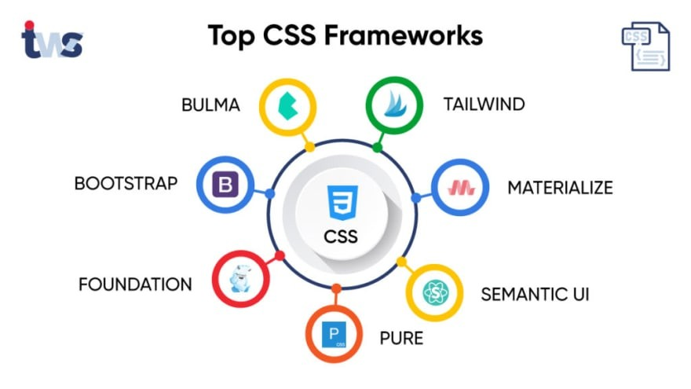

**14.3 Theming and Custom Design**

* The app implements Light/Dark Mode theming, allowing users to switch between light and dark visual styles for better usability and comfort depending on ambient lighting.
* Theming is managed globally, likely through React Context API or similar state management, enabling consistent theme toggling across all UI components.
* Custom configurations and extensions in Tailwind’s config may be used to tailor colors, fonts, and spacing specifically for FitFlex’s brand identity.
* Tailwind allows light/dark mode theming and custom design tokens to maintain consistent branding across the app with ease.
* flexibility, maintainability, and rapid UI development without writing extensive custom CSS files, focusing instead on composing small utility classes to build up component styles.

**15. Testing:**

**15.1. Testing Strategy:**

* Unit Testing: Focuses on testing individual React components or functions in isolation. Jest is the test runner providing the environment to write and run tests, while React Testing Library offers utilities to render components, simulate user events, and make assertions on the rendered output. This helps verify that each component renders correctly and behaves as expected with given props and states.
* Integration Testing: Tests interaction among multiple components or modules to ensure they work together properly. React Testing Library encourages testing from the user's perspective, interacting with component DOM elements as users would (clicks, typing, navigation), reducing reliance on internal implementation details.
* End-to-End Testing: While Jest and RTL cover unit and integration tests, tools like Cypress or similar can be used to automate full app workflows from start to finish in a real browser environment, ensuring the entire user journey functions smoothly.

**15.2 Code Coverage and Tools:**

* Jest includes built-in code coverage tooling that tracks how much of the codebase is tested by the unit and integration tests. Coverage reports indicate lines, branches, and functions tested, identifying untested code areas.
* Snapshots managed by Jest capture rendered component outputs to easily detect unintended UI changes during refactoring.
* Mocking features of Jest isolate component tests by simulating dependencies or API calls.
* The combination of Jest and React Testing Library promotes clear, maintainable, and user-centric testing, aligned with best practices in professional React development.

**16.Screenshots and Demo:**

* **Hero Page:**

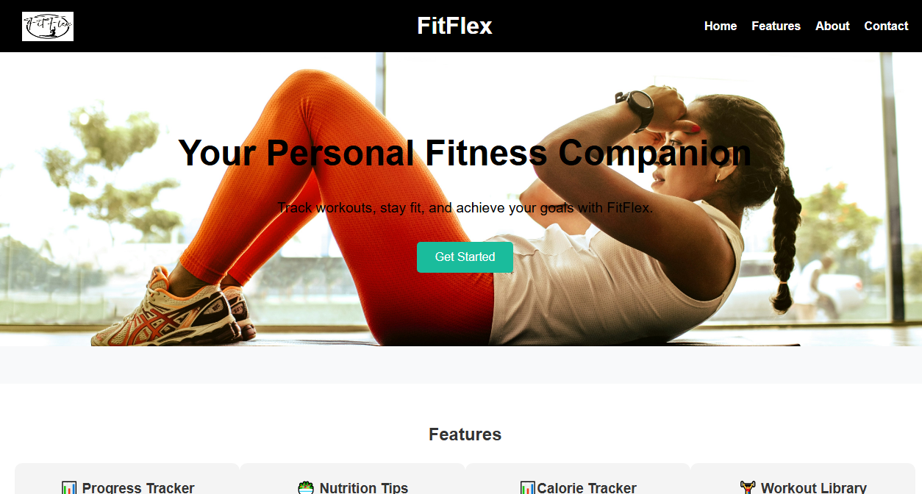

* **Feature and About:**

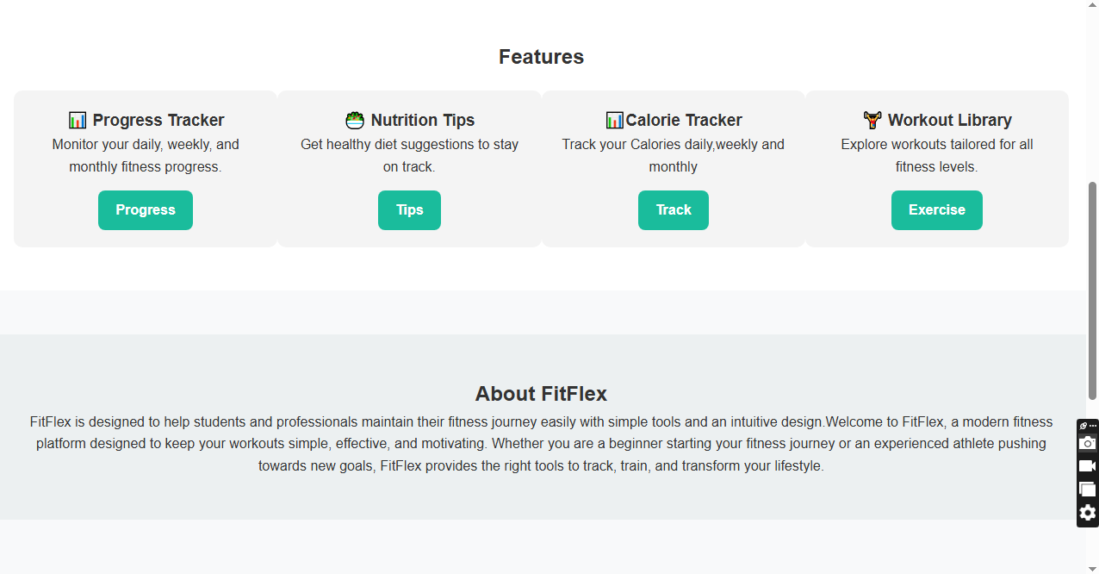

* **Contact Us:**

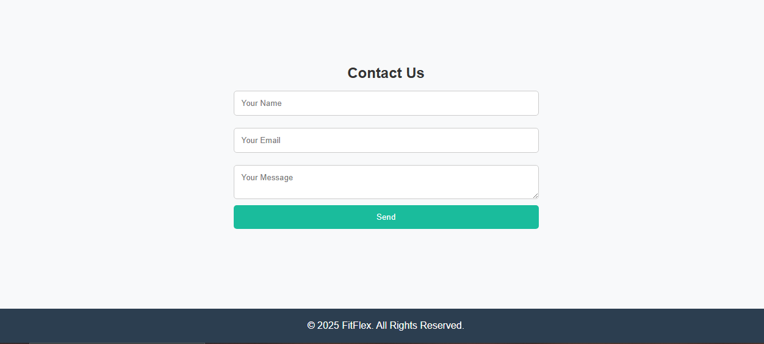

**SUB PAGES**

* **Progress Tracker Page:**

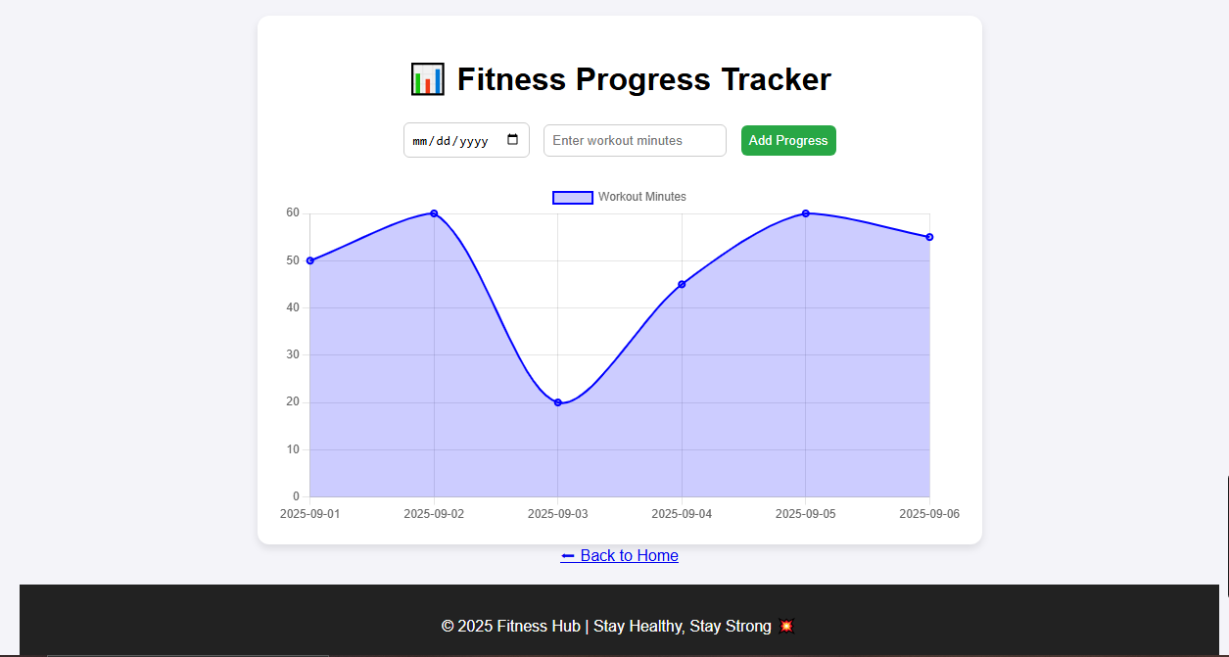

* **Nutritional Tips Page:**
* **Diet Tips:**

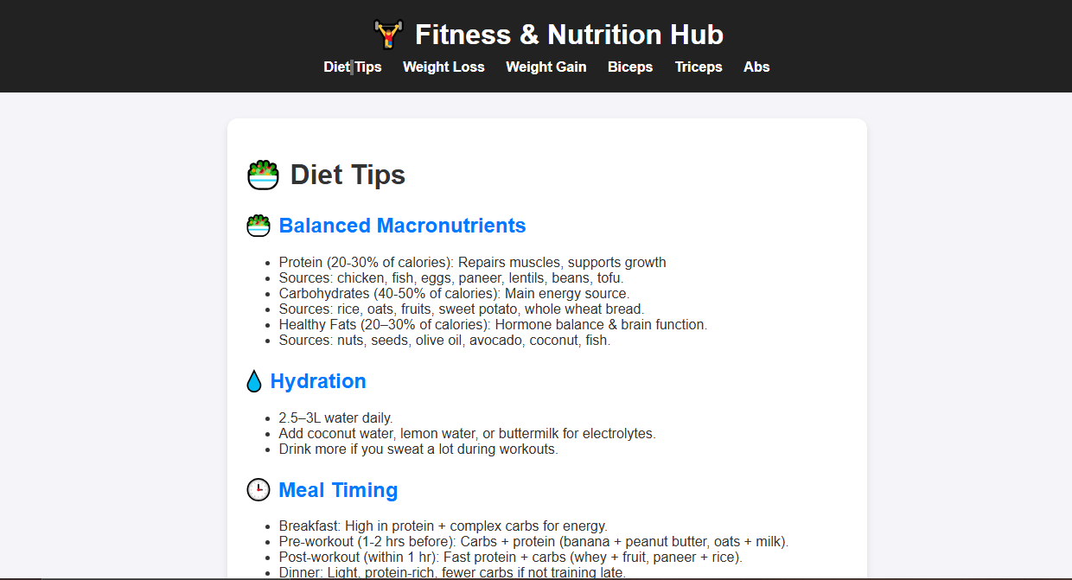

* **Weightloss Tips:**

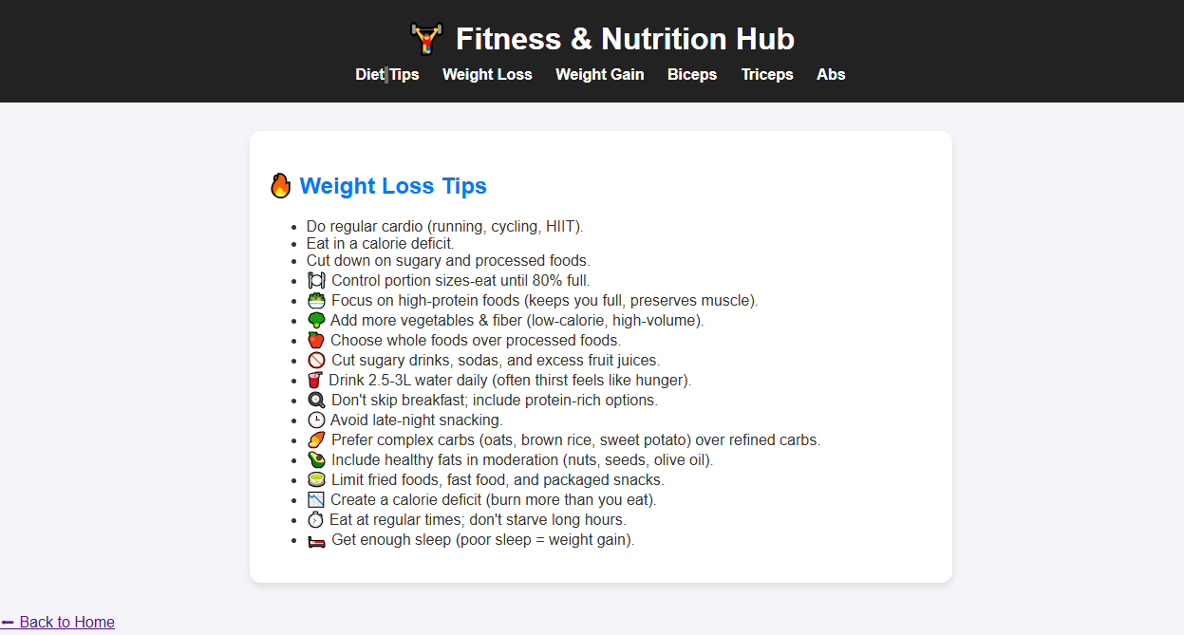

* **Weight Gain Tips:**

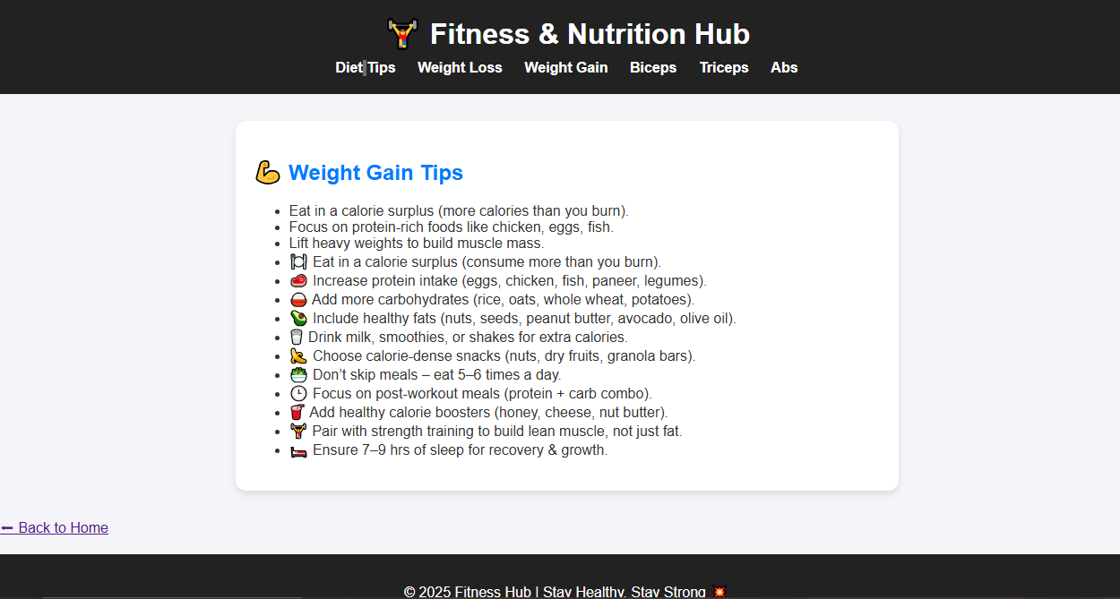

* **Biceps:**

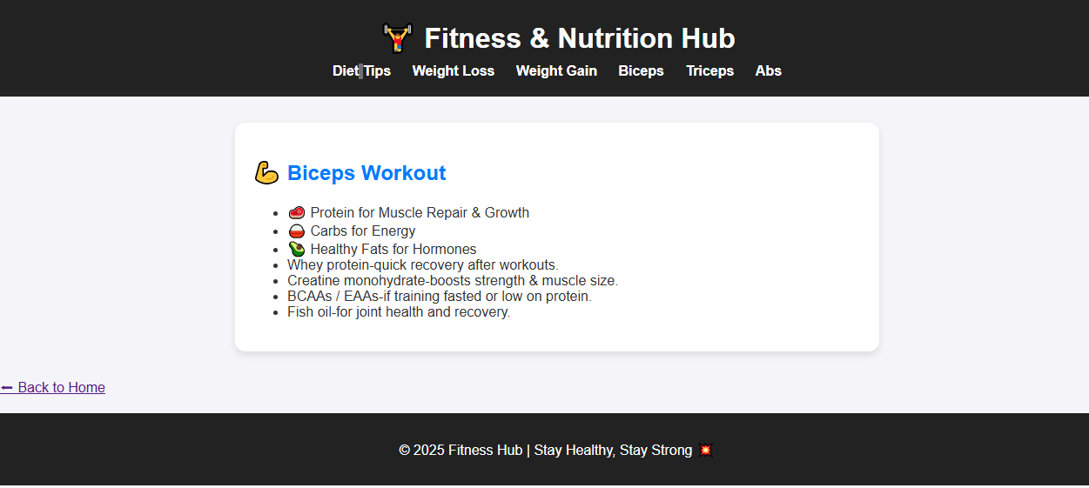

* **Triceps:**

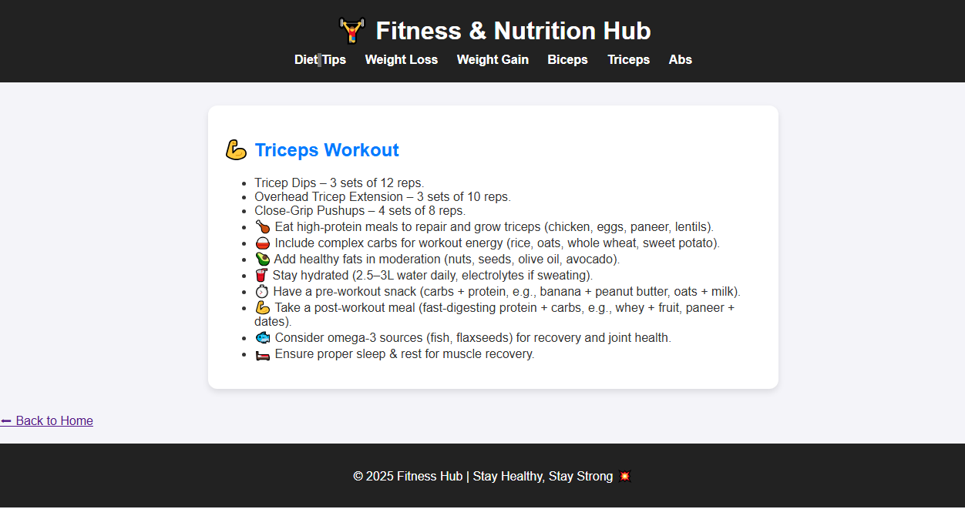

* **Abs:**

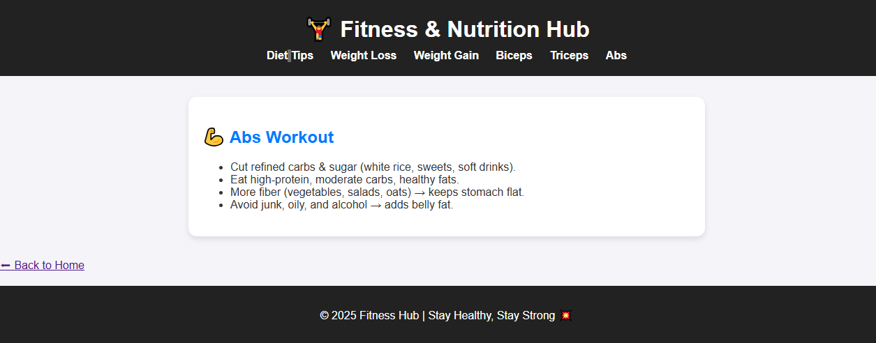

* **Calorie Tracker Page:**



* **Workout Library Page:**

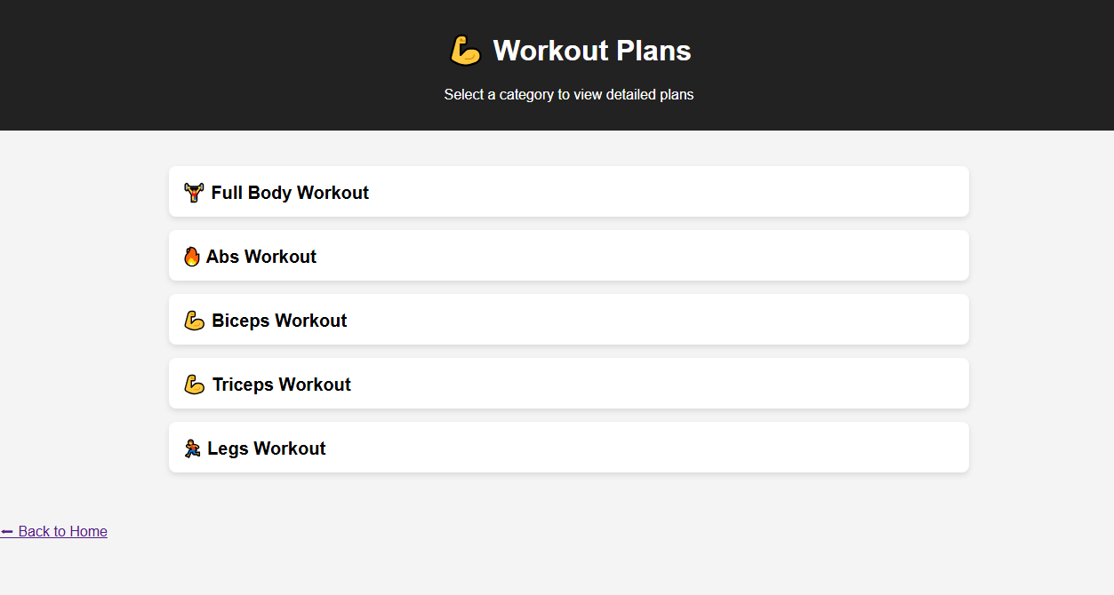

**DEMO LINK:**

https://drive.google.com/drive/folders/134K-uqIw61D2X0oO9vkQnCJ7CGJVPKPF?usp=sharing

**17.Future Enhancements:**

* **User Accounts & Profiles** – Allow users to create personal profiles to save workout routines, diet plans, and progress history.
* **Progress Tracking Dashboard** – Add features like weight tracking, BMI calculator, calorie counter, and progress charts.
* **AI-Based Workout Suggestions** – Use AI to recommend personalized workout and nutrition plans based on user goals.
* **Video Tutorials & Live Sessions** – Integrate workout videos or live streaming for better guidance.
* **Community & Forums** – Create a space where users can connect, share tips, and motivate each other.
* **Mobile App Integration** – Extend Fitflex into a mobile application for easier access on smartphones.
* **Wearable Device Sync** – Sync data with fitness trackers or smartwatches to monitor heart rate, steps, and calories burned.
* **Gamification** – Introduce badges, challenges, and rewards to keep users motivated.
* **Multilingual Support** – Provide fitness tips and plans in different languages to reach a wider audience.

**18.Conclusion:**

The Fitflex project serves as a complete fitness companion by combining workout routines, nutritional tips, and progress tracking in one platform. It highlights the importance of maintaining a healthy lifestyle while making fitness resources simple, accessible, and engaging for users of all levels. By integrating HTML, CSS, JavaScript, and React.js, the project not only demonstrates the technical aspects of web development but also addresses real-life needs in health and fitness. With future enhancements like user profiles, AI-based suggestions, and community features, Fitflex has the potential to evolve into a powerful fitness hub that motivates and supports individuals in achieving their personal health goals.